**Cell Cycle Webquest**  Name_____________________hr____

Go to hasd.org and sign in to **Canvas site** to use hyperlinks.

1. **Why Must a Cell Divide?**

* CLICK ON: <http://plaza.ufl.edu/alallen/pgl/modules/rio/stingarees/module/why.html>

1. Why can’t a cell continue to get bigger instead of dividing? In other words, why are cells limited by size?

* **Click on “What Does Mitosis Do?” on the left-hand side.**

1. What are the 2 main functions of mitosis?

1. What types of cells DO NOT divide?
2. When might mitosis occur in your body? Give specific examples?

* **Click on “Built-in Controls in Mitosis” (left-hand side).**
* **Click on the arrow to advance the animation.**

1. What do cells have that control cell division?

1. What happens if mutations occur in these regulatory factors?

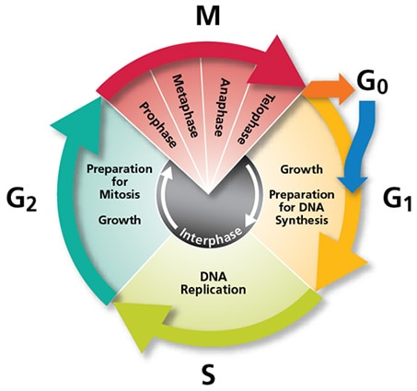

1. **Cell Cycle:** click on [**http://www.cellsalive.com/cell_cycle.htm**](http://www.cellsalive.com/cell_cycle.htm)
2. What is the cell cycle ?

* **Click on “Start the Animation” (Big red button)**

1. What are the four steps in the given cell cycle diagram (by color)?
2. What is interphase and what occurs during this step in the cell cycle?
3. What happens during Gap 1 (G1) of the cell cycle?

1. What happens during S phase of the cell cycle?

1. What happens during Gap 2 (G2) of the cell cycle?

1. What happens during M phase (mitosis) of the cell cycle?

(What is all the energy of the cell focused on in this phase?)

* **Click the Play Symbol (triangle) under the diagram of the eukaryotic cell cycle to find the names and function of the 3 checkpoints. (It will stop at**

1. What are the names of the 3 checkpoints called and what are they checking in the cell cycle?

|  |  |  |
| --- | --- | --- |
|  | Checkpoint name | What does it check for? (Question) |
| 1. |  |  |
| 2. |  |  |
| 3. |  |  |

1. Label the missing phases on the diagram

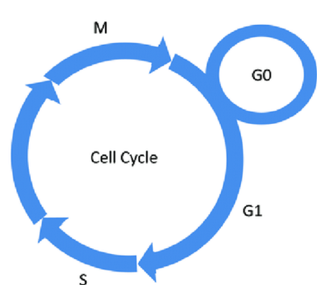

1. Go To Quizlet and practice your terms.

Quizlet: BIO 7.1 Cell Division Here is a link: https://quizlet.com/_4bxwct